ICS-344 - Information Security
Section 02
Your DVSA Website URL:
http://dvsa-website-test-546079881937-us-east-1.s3-website.us-east-1.amazonaws.com/
AWS Region:
us-east-1 (N.Virginia)
Date: 3 May 2026
Vulnerability Title(s):
CORS Misconfiguration
Bonus

Goal and Vulnerability Summary
This task demonstrates a CORS misconfiguration in the DVSA API where the backend allows requests from any origin using a wildcard (*). The goal is to show that a malicious website can access sensitive API responses and then apply a fix to restrict access to only the trusted DVSA frontend.

Why This Works / Root Cause
The vulnerability exists because the Lambda function returns the header:
Access-Control-Allow-Origin: *
This allows any domain to access the API. Since DVSA uses Lambda proxy integration, CORS headers are controlled by the Lambda response instead of API Gateway configuration.

Environment and Setup
- AWS Region: us-east-1
- DVSA deployed via Serverless Application Repository
- API Gateway endpoint:
  - https://h3x14rchv6.execute-api.us-east-1.amazonaws.com/dvsa/order
- Lambda Function:
  - DVSA-ORDER-MANAGER
- Tools:
  - Kali Linux terminal
  - curl

Reproduction Steps
- Send a normal API request:
curl -i "$API" \
-H "authorization: $TOKEN" \
--data-raw '{"action":"orders"}'
- Send request from malicious origin:
curl -i "$API" \
-H "Origin: http://evil.com" \
-H "authorization: $TOKEN" \
--data-raw '{"action":"orders"}'
- Observe response header:
Access-Control-Allow-Origin: *

- Modify Lambda code to restrict origin.
- Deploy Lambda.
- Re-run malicious origin request.

Evidence and Proof
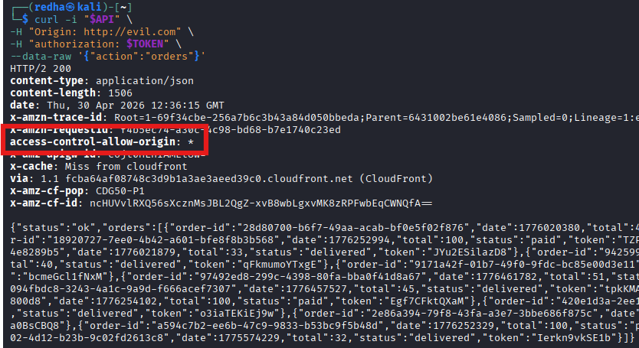
Figure 1: API response showing Access-Control-Allow-Origin: *

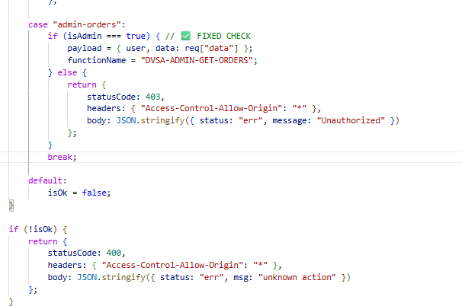
Figure 2: Lambda code showing wildcard origin

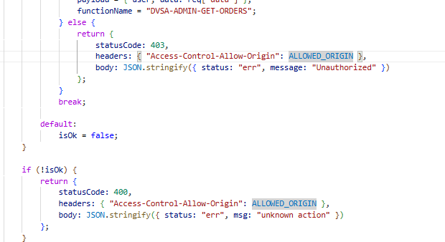
Figure 3: Updated Lambda code with restricted origin

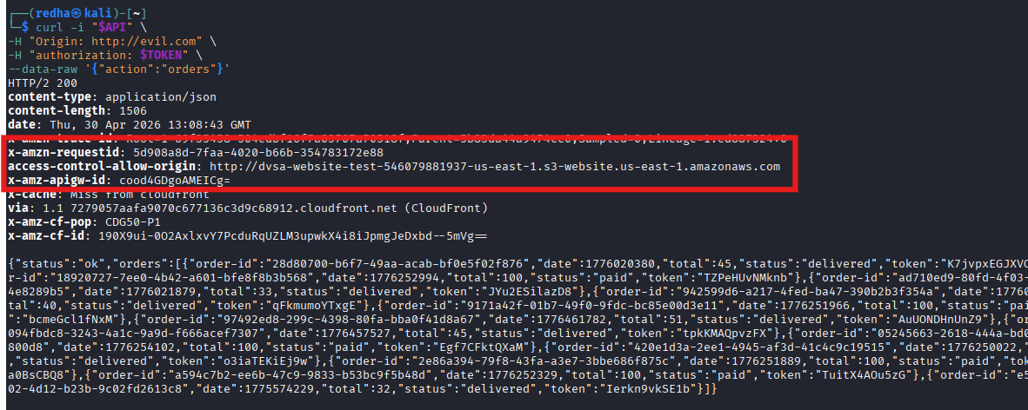
Figure 4: API response after fix showing restricted origin

This confirms that the API initially allowed all origins and was later secured.

Fix Strategy / Probable Mitigation
The fix is to restrict allowed origins to only the trusted frontend domain. Since the API uses Lambda proxy integration, the fix must be applied inside the Lambda response headers.

Code / Config Changes
Before:
headers: { "Access-Control-Allow-Origin": "*" }
After:
const ALLOWED_ORIGIN = "http://dvsa-website-test-546079881937-us-east-1.s3-website.us-east-1.amazonaws.com";

headers: { "Access-Control-Allow-Origin": ALLOWED_ORIGIN }

Verification After Fix
After applying the fix:
curl -i "$API" \
-H "Origin: http://evil.com" \
-H "authorization: $TOKEN" \
--data-raw '{"action":"orders"}'
Result:
access-control-allow-origin: http://dvsa-website-test-546079881937-us-east-1.s3-website.us-east-1.amazonaws.com
This confirms that the wildcard has been removed and only the trusted origin is allowed.

Structured Operation and Security Analysis

Table 1: Structured analysis summary — Table A
Vulnerability | Intended Rule(s) | Artifacts Used to Infer Rule | Normal Behavior Evi dence | Exploit Behavior Evi dence
CORS Misconfiguration | API should only allow trusted origins | curl output, response headers | Requests return data normally | Malicious origin is allowed and receives response

Table 2: Structured analysis summary — Table B:
Vulnerability | Why This Is a Deviation | Deviation Class | Fix Applied  (where) | Post-Fix Verification | Optional Latency Be fore / After Logging
CORS Misconfiguration | API allows any origin (*), violating origin restriction | Security misuse | Restricted origin in Lambda response headers | Malicious origin no longer allowed | N/A

Takeaway / Lessons
This task highlights the importance of proper CORS configuration in serverless applications. Allowing all origins exposes APIs to cross-site attacks and data theft. Secure design requires restricting access to trusted domains and understanding where CORS is enforced, especially in Lambda proxy integrations.

